ScienceQtech Employee Performance Mapping Project

Objective:

1. To facilitate a better understanding, managers have provided ratings for each employee which will help the HR department to finalize the employee performance mapping. (# Q.2)
2. As a DBA, you should find the maximum salary of the employees and ensure that all jobs are meeting the organization's profile standard. (# Q.13)
3. You also need to calculate bonuses to find extra cost for expenses. This will raise the overall performance of the organization by ensuring that all required employees receive training. (# Q.15)

Note: Please assume there's is a dataset with the same name been mentioned earlier.

Dataset description:

emp_record_table: It contains the information of all the employees.

EMP_ID – ID of the employee

FIRST_NAME – First name of the employee

LAST_NAME – Last name of the employee

GENDER – Gender of the employee

ROLE – Post of the employee

DEPT – Field of the employee

EXP – Years of experience the employee has

COUNTRY – Country in which the employee is presently living

CONTINENT – Continent in which the country is

SALARY – Salary of the employee

EMP_RATING – Performance rating of the employee

MANAGER_ID – The manager under which the employee is assigned

PROJ_ID – The project on which the employee is working or has worked on

Proj_table: It contains information about the projects.

PROJECT_ID – ID for the project

PROJ_Name – Name of the project

DOMAIN – Field of the project

START_DATE – Day the project began

CLOSURE_DATE – Day the project was or will be completed

DEV_QTR – Quarter in which the project was scheduled

STATUS – Status of the project currently

Data_science_team: It contains information about all the employees in the Data Science team.

EMP_ID – ID of the employee

FIRST_NAME – First name of the employee

LAST_NAME – Last name of the employee

GENDER – Gender of the employee

ROLE – Post of the employee

DEPT – Field of the employee

EXP – Years of experience the employee has

COUNTRY – Country in which the employee is presently living

CONTINENT – Continent in which the country is

The task been performed:

Created a database named employee, then imported data_science_team.csv proj_table.csv and emp_record_table.csv into the employee database from the given resources (lsm).

Ans. CREATE DATABASE employee;

# Q.1

Write a query to fetch EMP_ID, FIRST_NAME, LAST_NAME, GENDER, and DEPARTMENT from the employee record table, and make a list of employees and details of their department.

Ans.

SELECT EMP_ID, FIRST_NAME, LAST_NAME, GENDER, DEPT AS DEPARTMENT

FROM emp_record_table;

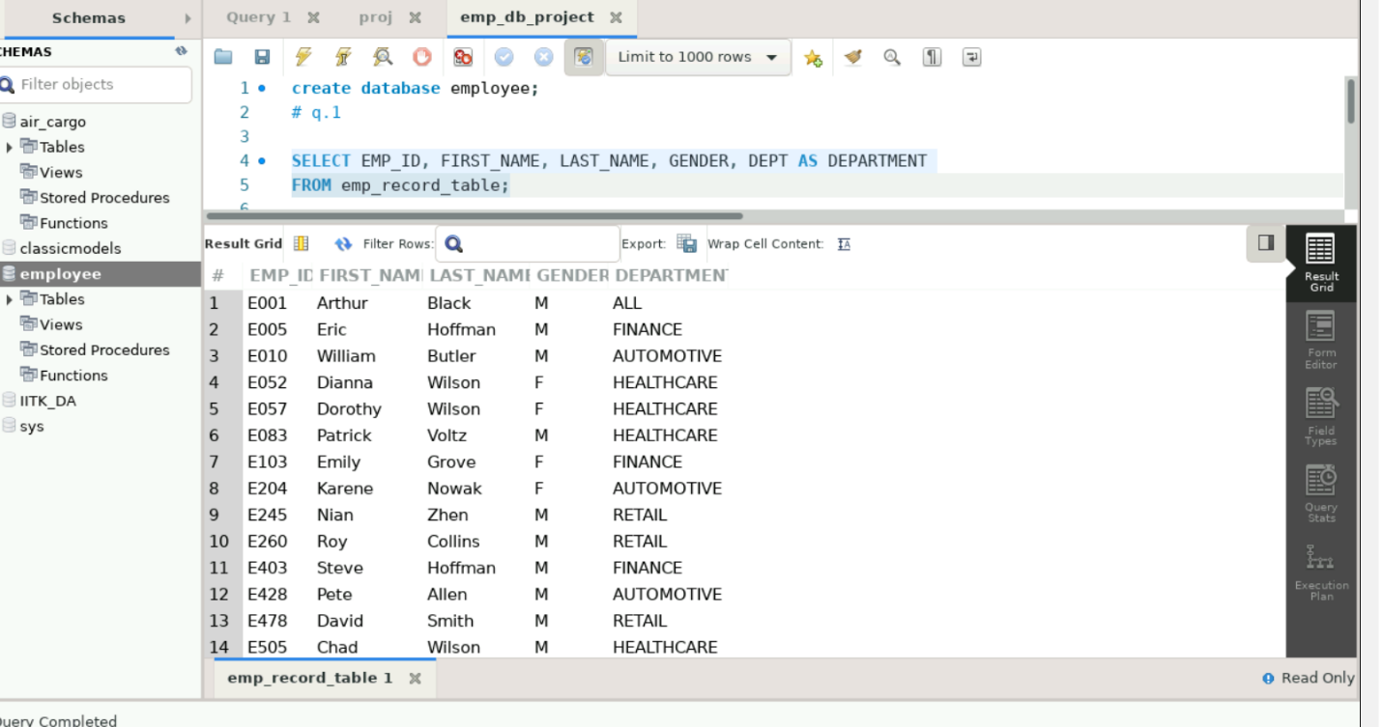

# Q.2

Write a query to fetch EMP_ID, FIRST_NAME, LAST_NAME, GENDER, DEPARTMENT, and EMP_RATING if the EMP_RATING is:

less than two (poor)

greater than four (Good)

between two and four (Average)

SELECT EMP_ID, FIRST_NAME, LAST_NAME, GENDER, DEPT AS DEPARTMENT, EMP_RATING

FROM emp_record_table

WHERE EMP_RATING < 2 OR EMP_RATING > 4 OR (EMP_RATING >= 2 AND EMP_RATING <= 4);

#to give ratings a name:

SELECT EMP_ID, FIRST_NAME, LAST_NAME, GENDER, DEPT AS DEPARTMENT, EMP_RATING,

case

when EMP_RATING < 2 then "Poor"

when EMP_RATING between 2 AND 4 then "Average"

when EMP_RATING > 4 then "Good"

else "NA"

end as Performance FROM emp_record_table;

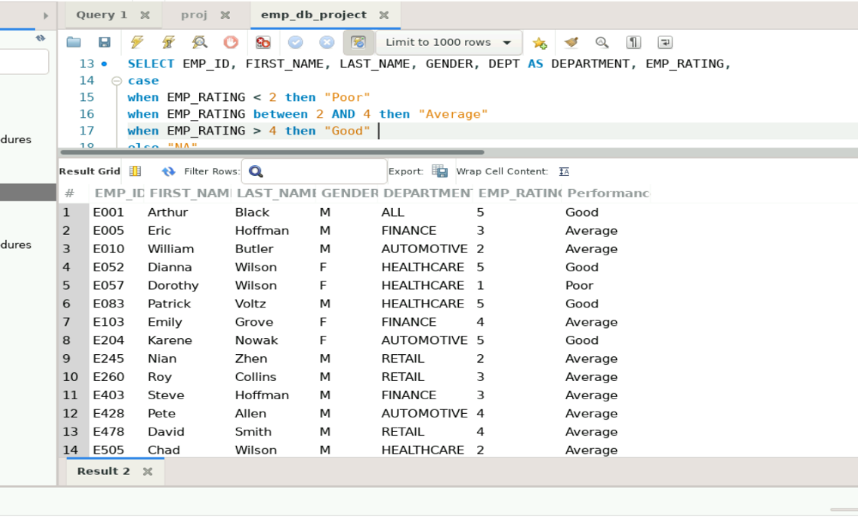

(Above image is for 2nd query)

# Q.3

Write a query to concatenate the FIRST_NAME and the LAST_NAME of employees in the Finance department from the employee table and then give the resultant column alias as NAME.

Ans.

SELECT CONCAT(FIRST_NAME, ' ', LAST_NAME) AS NAME

FROM emp_record_table

WHERE DEPT = 'Finance';

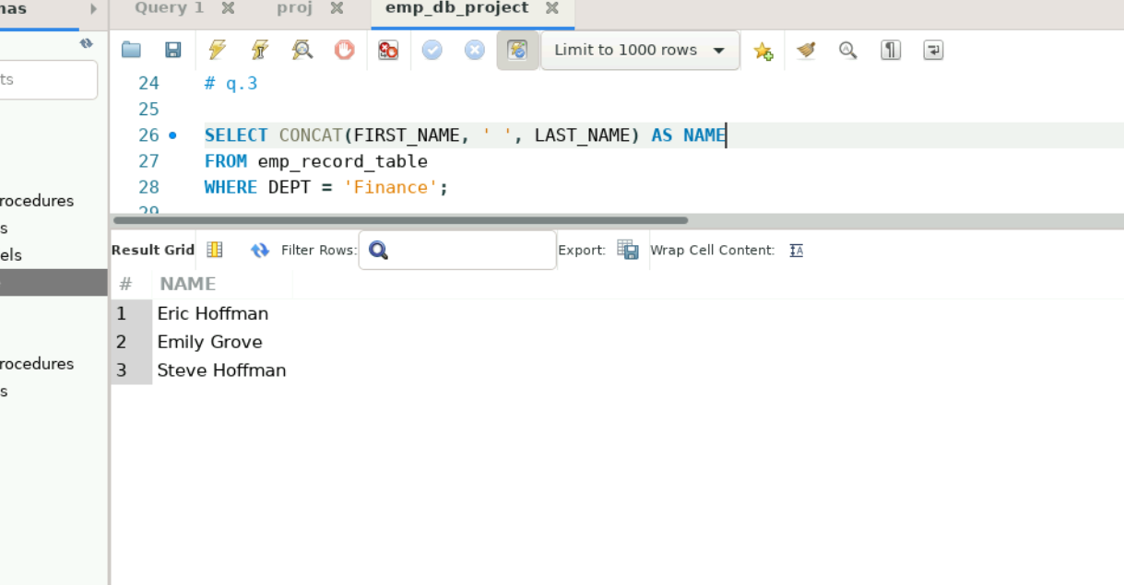

(Above image is for 3rd query)

# Q.4 Write a query to list only those employees who have someone reporting to them. Also, show the number of reporters (including the President).

Ans.

SELECT E1.EMP_ID, E1.FIRST_NAME, E1.LAST_NAME, E1.DEPT AS DEPARTMENT, COUNT(E2.EMP_ID) AS REPORTERS

FROM emp_record_table E1

LEFT JOIN emp_record_table E2 ON E1.EMP_ID = E2.MANAGER_ID

GROUP BY E1.EMP_ID, E1.FIRST_NAME, E1.LAST_NAME, E1.DEPT

HAVING COUNT(E2.EMP_ID) > 0;

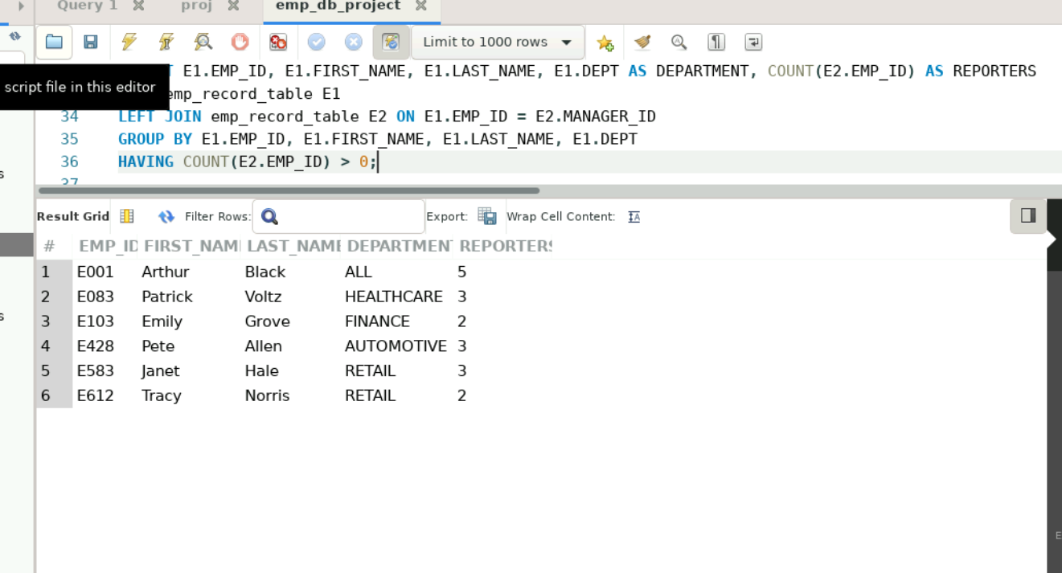

(Above image is for 4th query)

# Q.5

Write a query to list down all the employees from the healthcare and finance departments using union. Take data from the employee record table.

Ans.

SELECT EMP_ID, FIRST_NAME, LAST_NAME, DEPT AS DEPARTMENT

FROM emp_record_table

WHERE DEPT = 'Healthcare'

UNION

SELECT EMP_ID, FIRST_NAME, LAST_NAME, DEPT AS DEPARTMENT

FROM emp_record_table

WHERE DEPT = 'Finance';

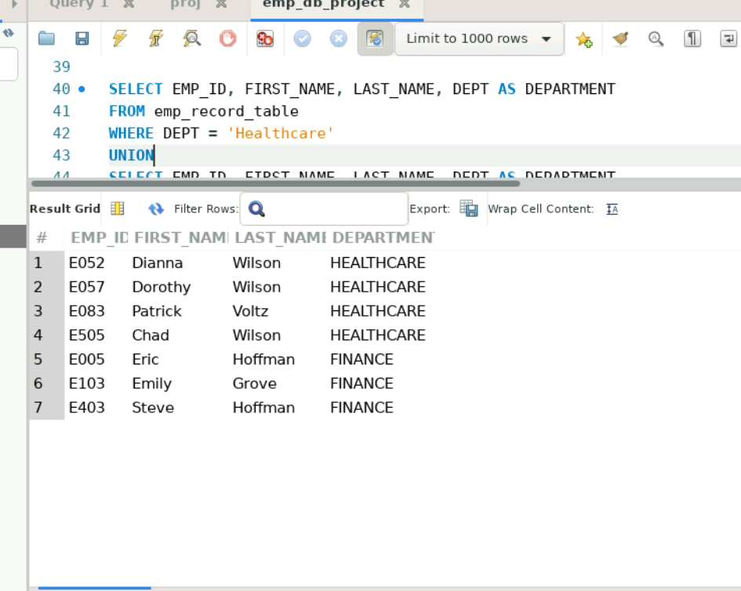

(Above image is for 5th query)

# Q.6

Write a query to list down employee details such as EMP_ID, FIRST_NAME, LAST_NAME, ROLE, DEPARTMENT, and EMP_RATING grouped by dept. Also include the respective employee rating along with the max emp rating for the department.

Ans.

SELECT E1.DEPT AS DEPARTMENT, E1.EMP_ID, E1.FIRST_NAME, E1.LAST_NAME, E1.ROLE, MAX(E2.EMP_RATING) AS MAX_EMP_RATING

FROM emp_record_table E1

LEFT JOIN emp_record_table E2 ON E1.DEPT = E2.DEPT

GROUP BY E1.DEPT, E1.EMP_ID, E1.FIRST_NAME, E1.LAST_NAME, E1.ROLE;

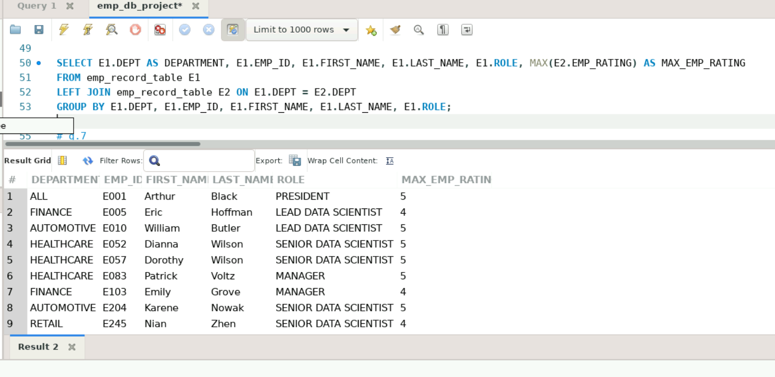

(Above image is for 6th query)

# Q.7

Write a query to calculate the minimum and the maximum salary of the employees in each role. Take data from the employee record table.

Ans.

SELECT ROLE, MIN(SALARY) AS MIN_SALARY, MAX(SALARY) AS MAX_SALARY

FROM emp_record_table

GROUP BY ROLE;

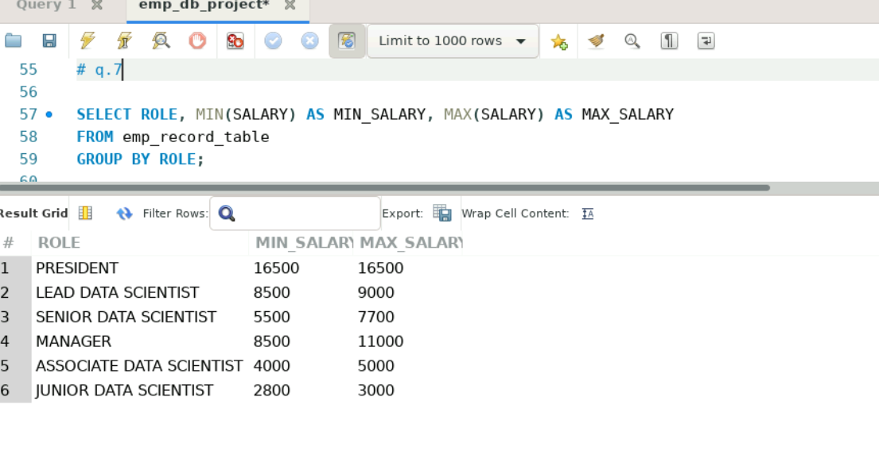

(Above image is for 7th query)

# Q.8

Write a query to assign ranks to each employee based on their experience. Take data from the employee record table.

Ans.

Select FIRST_NAME, LAST_NAME, ROLE, DEPT, EXP,

dense_rank() over (order by EXP desc) as “Ranking”

from emp_record_table;

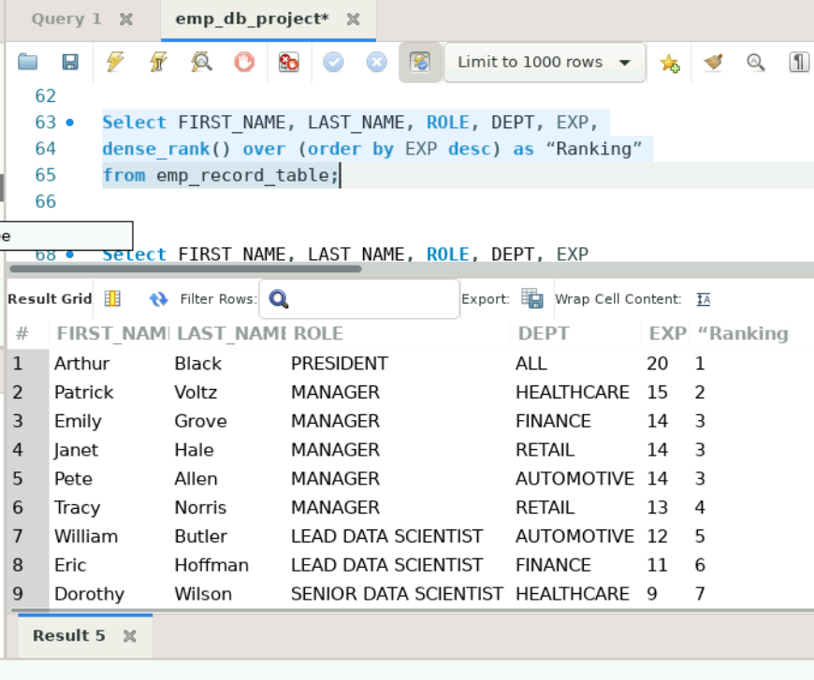

(Above image is for 8th query)

# Q.9

Write a query to create a view that displays employees in various countries whose salary is more than six thousand. Take data from the employee record table.

Ans.

CREATE OR REPLACE VIEW EmployeeSal AS

SELECT EMP_ID, FIRST_NAME, LAST_NAME, country, salary

FROM emp_record_table

WHERE salary> 6000;

SELECT * from EmployeeSal;

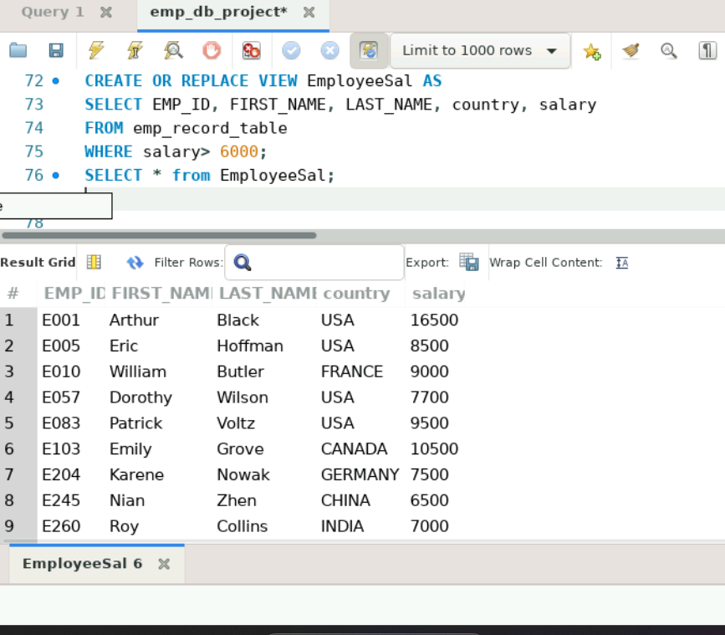

(Above image is for 9th query)

# Q.10

Write a nested query to find employees with experience of more than ten years. Take data from the employee record table.

Ans.

SELECT EMP_ID, FIRST_NAME, LAST_NAME, EXP

FROM emp_record_table

WHERE EXP > 10;

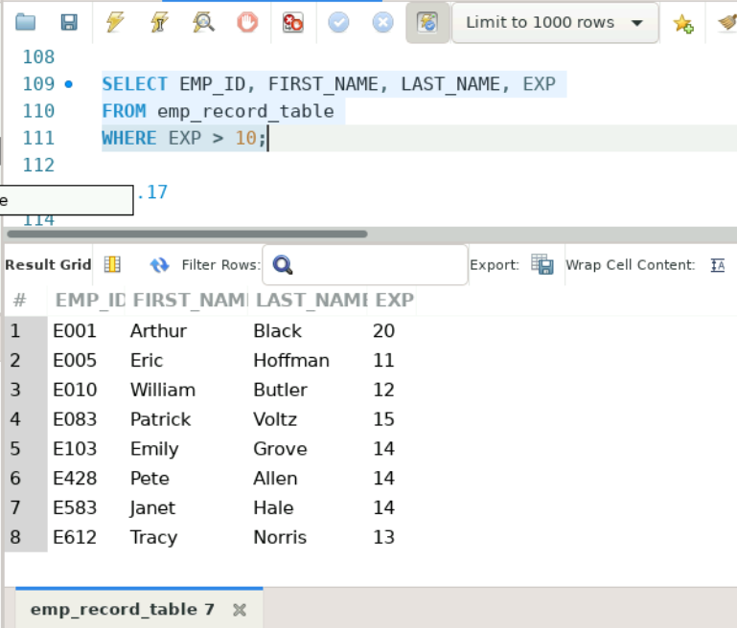

# Q.11

Write a query to create a stored procedure to retrieve the details of the employees whose experience is more than three years.

Ans.

DELIMITER //

CREATE PROCEDURE GetEmployeesWithExperience()

BEGIN

SELECT EMP_ID, FIRST_NAME, LAST_NAME, EXP

FROM emp_record_table

WHERE EXP > 3;

END//

DELIMITER ;

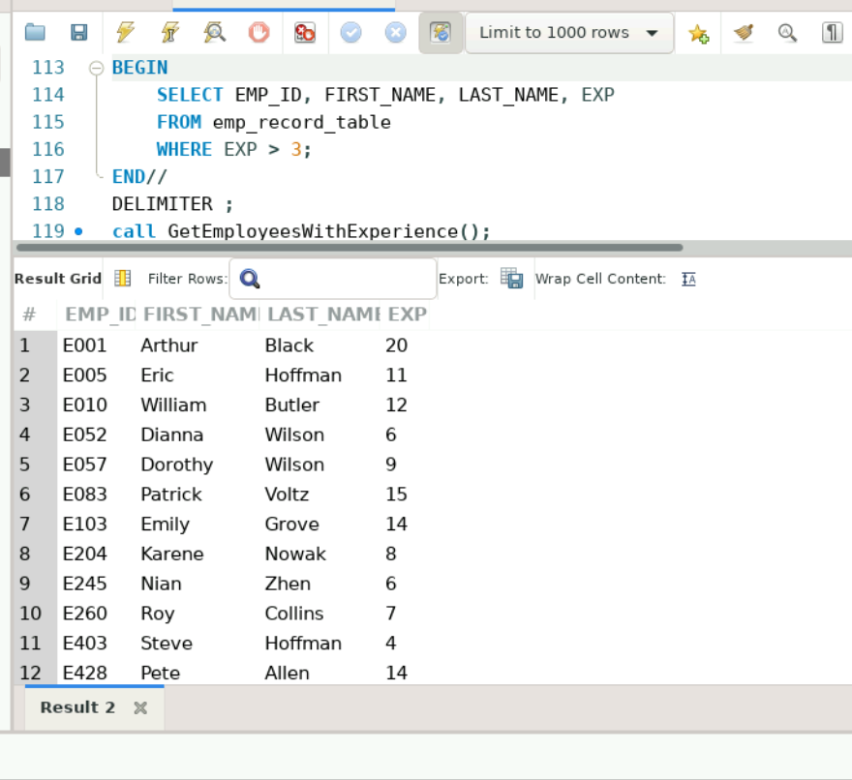

# Q.12

Write a query using stored functions in the project table to check whether the job profile assigned to each employee in the data science team matches the organization’s set standard.

The standard being:

For an employee with experience less than or equal to 2 years assign 'JUNIOR DATA SCIENTIST',

For an employee with the experience of 2 to 5 years assign 'ASSOCIATE DATA SCIENTIST',

For an employee with the experience of 5 to 10 years assign 'SENIOR DATA SCIENTIST',

For an employee with the experience of 10 to 12 years assign 'LEAD DATA SCIENTIST',

For an employee with the experience of 12 to 16 years assign 'MANAGER'.

Ans.

DELIMITER //

CREATE FUNCTION CheckJobProfile(EXP INT) RETURNS VARCHAR(50)

BEGIN

DECLARE JOB_PROFILE VARCHAR(50);

IF EXP <= 2 THEN

SET JOB_PROFILE = 'JUNIOR DATA SCIENTIST';

ELSEIF EXP <= 5 THEN

SET JOB_PROFILE = 'ASSOCIATE DATA SCIENTIST';

ELSEIF EXP <= 10 THEN

SET JOB_PROFILE = 'SENIOR DATA SCIENTIST';

ELSEIF EXP <= 12 THEN

SET JOB_PROFILE = 'LEAD DATA SCIENTIST';

ELSE

SET JOB_PROFILE = 'MANAGER';

END IF;

RETURN JOB_PROFILE;

END//

DELIMITER ;

-- Example of using the function: select * from employee.Employee_Ranks;

CREATE OR REPLACE VIEW EmployeeRanks AS

SELECT EMP_ID, FIRST_NAME, LAST_NAME, EXP,

CASE

WHEN EXP <= 2 THEN 'JUNIOR DATA SCIENTIST'

WHEN EXP <= 5 THEN 'ASSOCIATE DATA SCIENTIST'

WHEN EXP <= 10 THEN 'SENIOR DATA SCIENTIST'

WHEN EXP <= 12 THEN 'LEAD DATA SCIENTIST'

WHEN EXP <= 16 THEN 'MANAGER'

END AS RANK

FROM emp_record_table;

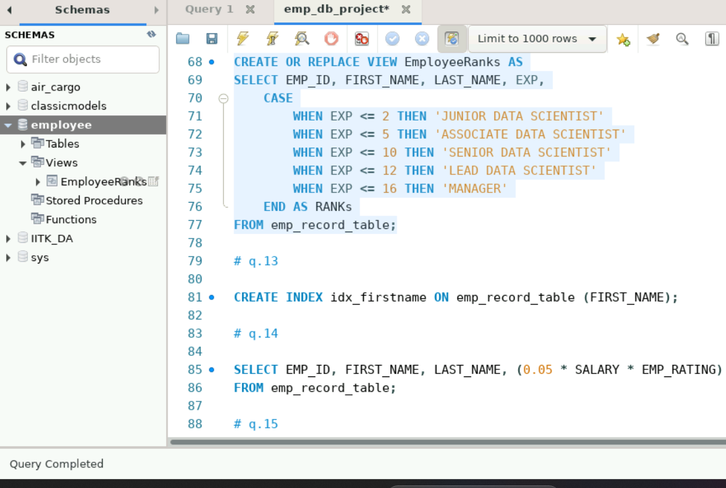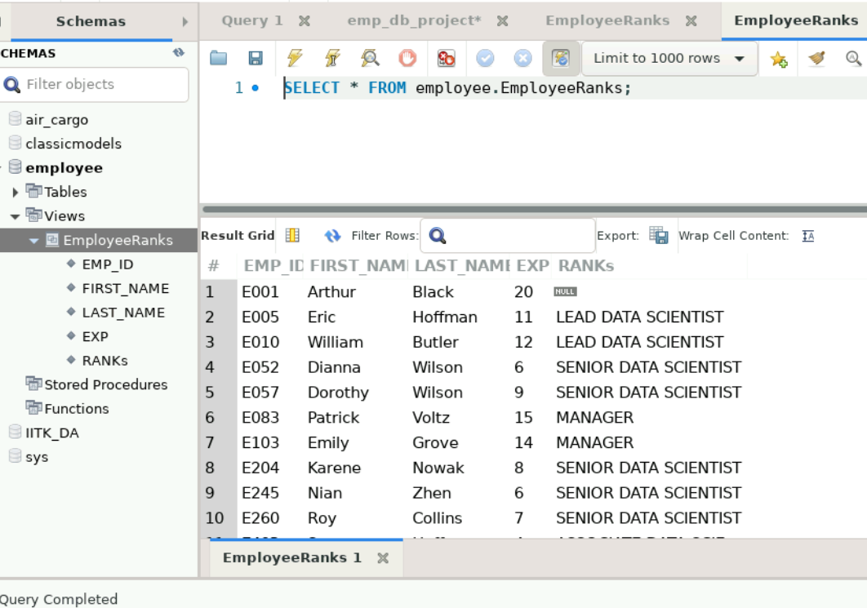

# Q.13

Create an index to improve the query performance for employees with 'Eric' as the FIRST_NAME:

Ans.

CREATE INDEX idx_firstname ON emp_record_table (FIRST_NAME(50));

SELECT * FROM emp_record_table WHERE first_name = 'Eric';

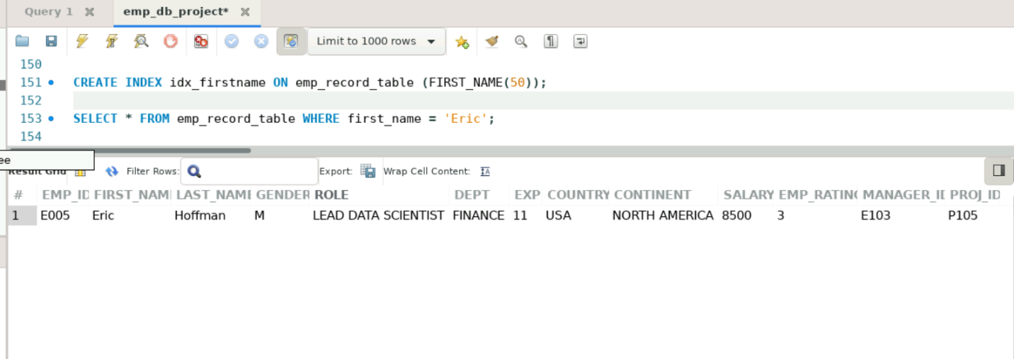

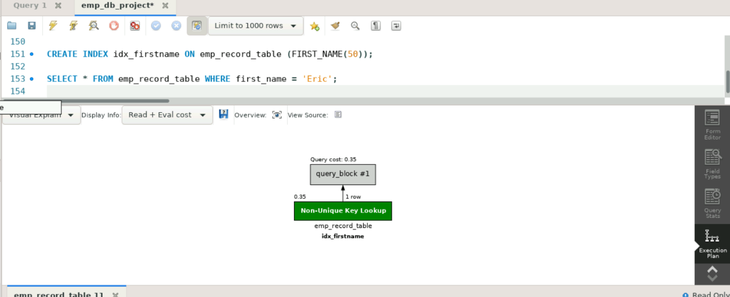

# Q.14

Write a query to calculate the bonus for all the employees, based on their ratings and salaries (Use the formula: 5% of salary * employee rating).

Ans.

SELECT EMP_ID, FIRST_NAME, LAST_NAME, (0.05 * SALARY * EMP_RATING) AS BONUS

FROM emp_record_table;

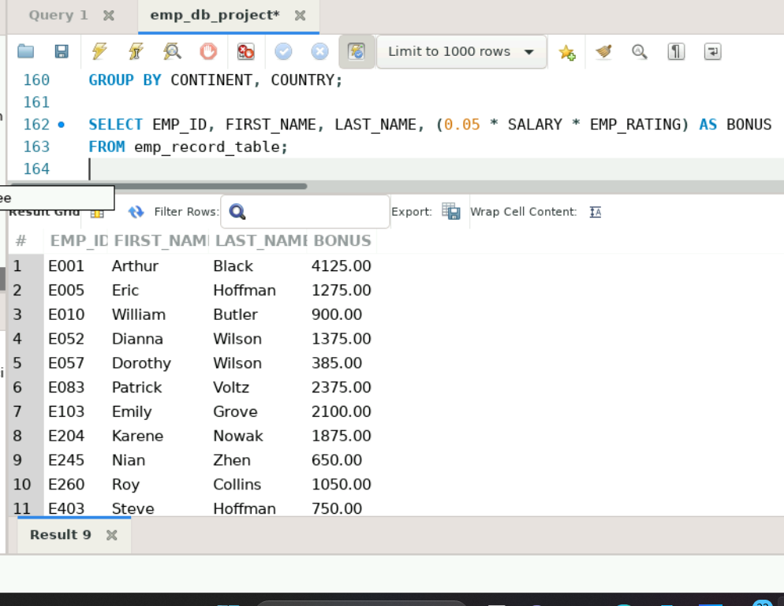

# Q.15

Write a query to calculate the average salary distribution based on the continent and country. Take data from the employee record table.

Ans.

SELECT CONTINENT, COUNTRY, AVG(SALARY) AS AVERAGE_SALARY

FROM emp_record_table

GROUP BY CONTINENT, COUNTRY;

